- Log on to correct environment
- Access //claimpos
- From the main Claim screen you can PF11 (searches all claims done for the current date). If there are no claims, enter the previous day in the Starting Date field on the main Claim search screen.
- Find a paid claim (a claim is paid if it has numbers in the Claim field)
Rejected = denied claims; Acc = reversal claims; Ones w/numbers = paid claims

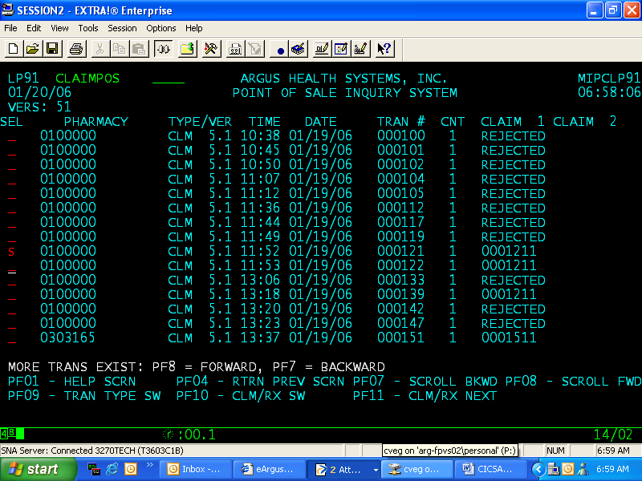

- Enter S (select) beside paid claim (Press enter key)
- Press PF9 key
- Press PF2 key

*******
Displayed is the “RAW” data that is related to the selected claim.

*******
This is changed depending on what you are attempting to process - the information on your ART and your test matrix.

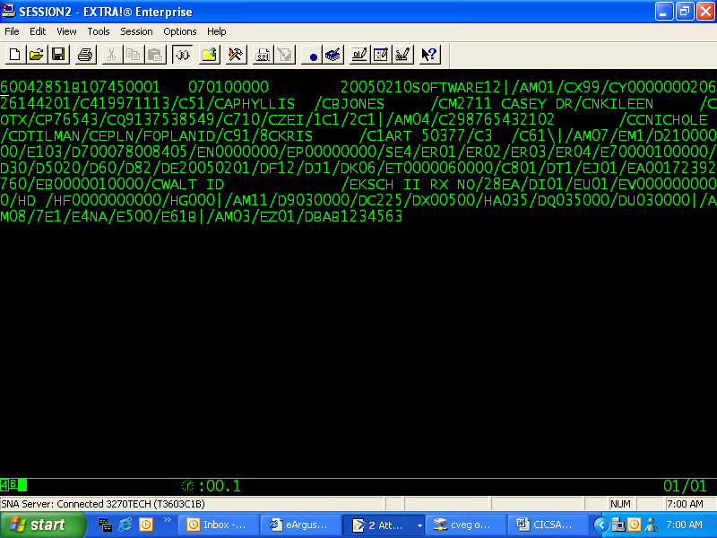

TIP: If you decide not to change or decide not to proceed, Press PAUSE, Enter W on blank screen, Press PF3 which will take you back to re-enter request, user id, password

*******See Billing Document that explains criteria for RAW data fields*******

TIPS:
1. Always enter AP16 at beginning of your claim (Header- Bin #) (don’t delete the last few #’s at the end of this field just enter AP16 over the 1st 4 digits).
2. Always increment by 1 the last 4 digits of the Date of Service on each claim (20050118 change to 20050119) so you can keep your claims separate – to reuse for more test conditions.
3. Change other RAW data fields that will apply to testing the ART
  - Use I (straight bar) as a segment divider (AMXX)
  - Use / as a field divider (C4)
VIP: Byte length must be maintained by data or blanks – Use Insert key to insert data if applicable.
4. Cherri Neises, Brian Showen, or Phyllis Jones will know how to submit AMO5 for up to 3 other payers (see your “Claims Bible”).

After you’ve changed the RAW data you want to submit the claim as follows:

1. Press ENTER (will receive blank screen)
- Press ENTER (will receive messages - so if testing messages, will need to peruse, if not, then continue)
- Press PAUSE key
- Type W – displays on screen (this takes you to the wake up screen – where you will need to re-enter the environment); Press ENTER
- Enter //claimpos, User ID and Password; press ENTER
- Once you’ve narrowed your search by utilizing suggestions in the next TIPS list, and your claim is not listed, press PF 8 forward (displays the next page of claims for the search criteria that was entered in the previous search screen).
- If the claim is not completed – Press PF4 and the start over with Step 5

TIPS:
  - If want all claims processed today press PF11
  - If you want a specific processed claim list for a customer you must enter Customer Number in the additional search area
  - If you want a specific processed claim list for a customer with prior date you must enter Start Date and then Customer Number in the additional search area

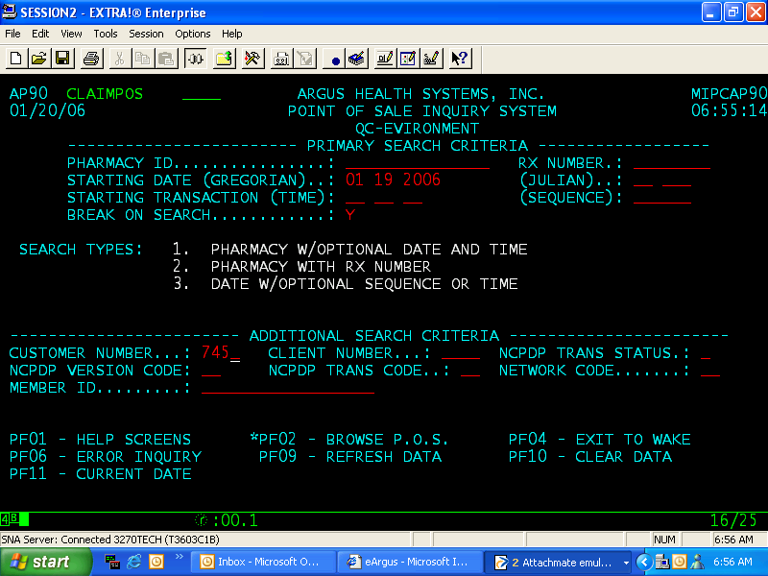

TIP: If you want to submit another claim and use same RAW data as previous claim submitted just change one of the following:
Member #; Fill Date; NDC (To make a different claim without looking up new NDC # change date of service field); RX #

